Kola Company Project Part 3
Student Name
Institution Affiliation

  - Final scope statement
The project management for the Kola company will have a baseline set, to ensure that new changes in progress or completion are recorded for project completion analysis. The cost in project may vary in actual cost with that in the plan or baseline cost. Some of the project task will be complete and update in the project schedule. The actual completion date, duration, remaining duration and actual cost of the project will be included.
The update of the project will show the variation in the cost. The project performance is measured using variation such as the comparison in baseline cost and actual cost and that of time (Dionisio, 2019). The baseline cost and schedule of the project may have variation due to various risk.
  - Risk Management plan

Risk Assessment Table
Rank | Risk Event | Likelihood(5-1) | Impact(5-1) | Detection Difficulty(5-1) |  |  | Score
1 | Risk 1: Market Competition | 4 | 2 | 4 |  |  | 3
2 | Risk 2: Legal Risk | 3 | 4 | 2 |  |  | 3
3 | Risk 3: Financial Risk | 4 | 3 | 4 |  |  | 4
4 | Risk 4 : Lack raw materials | 2 | 2 | 3 |  |  | 2
5 | Risk 5: Technical expert | 1 | 3 | 2 |  |  | 2

Risk Response Matrix
Score | Risk Event |  | Response |  | Contingency Plan |  | Trigger | Responsible
 | Risk 1: Market Competition |  | Carry out another research |  | Hire independent research |  | Low sales | Marketing
 | Risk 2: Legal Risk |  | Higher legal fir for technical assistance |  | Contact alternative legal firm for guidance |  | Law suits | Legal
 | Risk 3: Financial Risk |  | Assign supplementary budget. |  | Having supplementary budget |  | Under budget | R&D
 | Risk 4 : Lack raw materials |  | Looking for more reliable suppliers |  | Having alternative suppliers |  | Low supply | Purchase

  - Tracking Gantt Chart picture with baseline

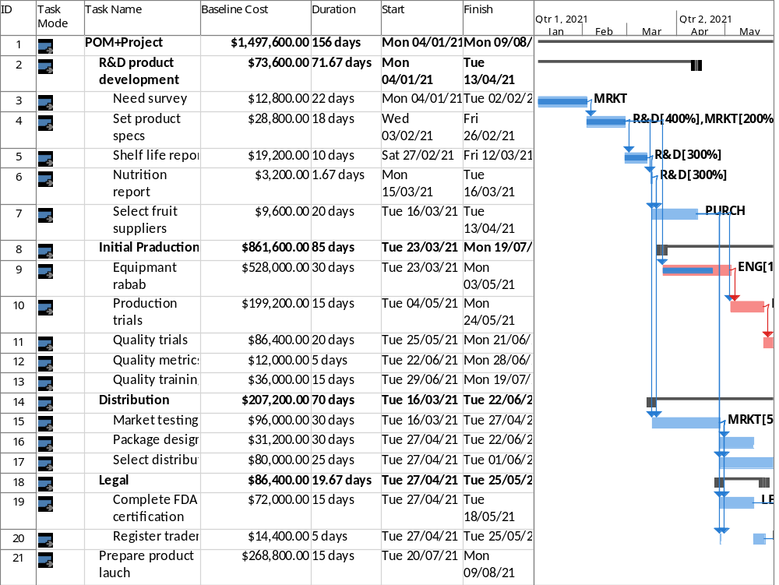
Questions part 3
How much will the project cost? What is the most expensive activity?
Prepare product launch will be the most expensive task. The cost will be $268,800
What does the cash flow statement tell you about how costs are distributed over life span of the project?
The cash flows show gradual rise in in the cumulative cost of the project. The actual cost is higher than the baseline cost.
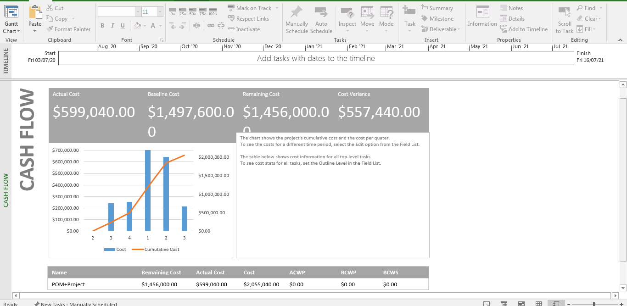

Reference
Dionisio, C. (2019). Microsoft Project 2019 for dummies. John Wiley & Sons, Inc.

